Photos from different angles:

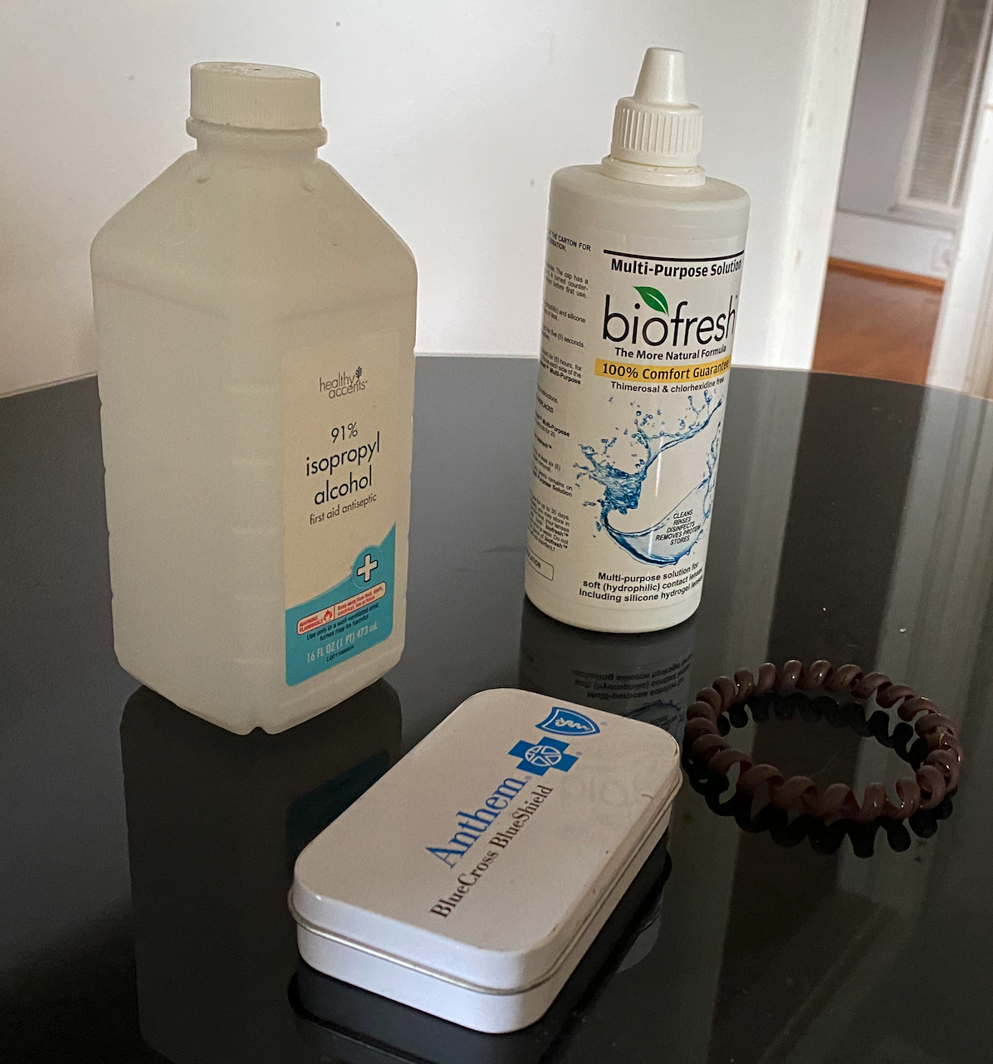

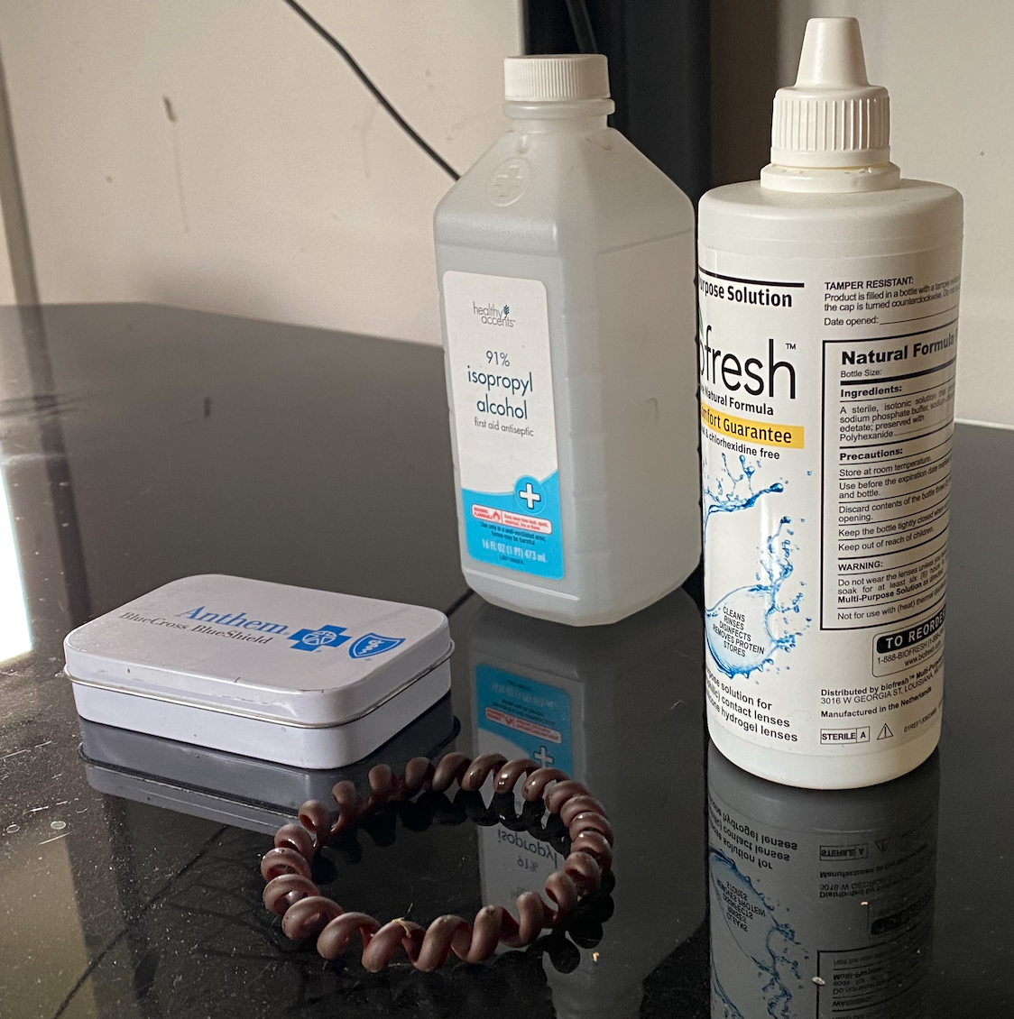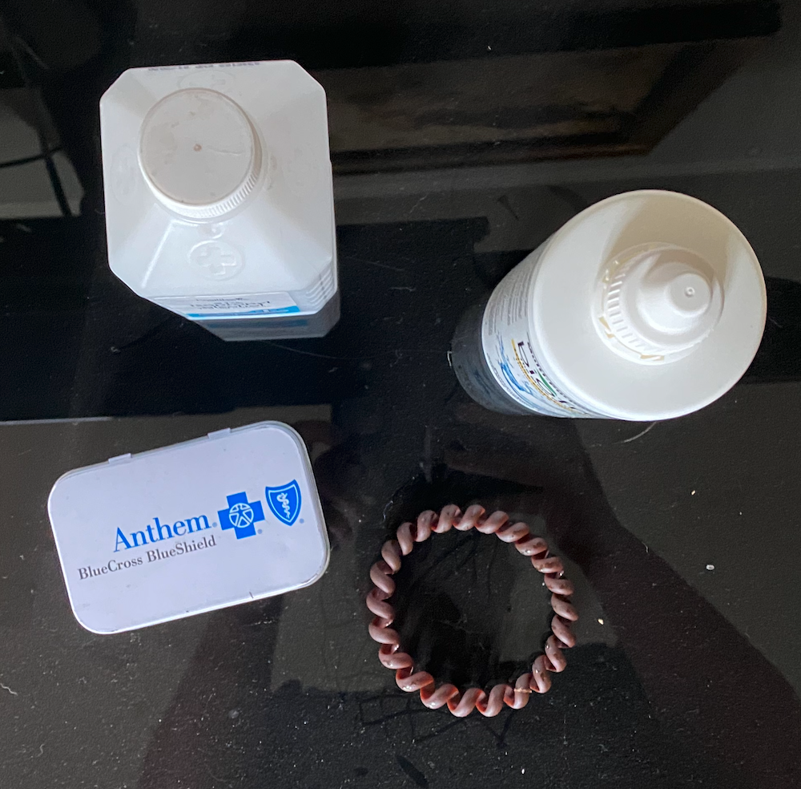

Requirements:

1. Must have **four** objects
2. At least one object made of **two** or more primitive shapes
3. At lease **four** primitive shapes

Objects in the space:

1. Alcohol bottle - the base of the bottle is made of a rectangular cube. The bottom corners of the bottle are beveled and could be challenging to recreate. It might be possible to round the edges with a sphere shape to give the appearance of beveled corners.
   1. This object meets the second requirement since it is made of a rectangular cube, rectangular pyramid and a cylinder on top.
2. Tin container - this is a simple cube with curved edges. Since the edges are curved, I would attempt to use cylinders on the corners to give the look of one object with curved edges.
3. Contact solution - the main part of the bottle is a cylinder.
   1. This object also meets the second requirement since it is made of a large cylinder, a small cylinder as the base of the cap and a cone at the very top. The cone shape would start out as a pyramid shape but the amount of surfaces of that pyramid would increase to give the appearance of a cone.
4. Hair tie - this object is a torus but is made of a spiral. To keep the shape simple, I would first create the torus shape. If possible, I would like to add the spiral detail in this object.
5. The table surface - this is a plane that is somewhat reflective. To keep the project simple, I would not add the reflective properties to this scene but if I was able to, it would help create depth and would feel much more three dimensional.

I think this scene would be ideal to recreate as it includes several primitive shapes and contains details that could be added in the process. For example, the raised detail on the alcohol bottle could be added as well as the texture on the cap of the contact solution bottle. The shapes are simple but detail could be added to make the project challenging. When starting the project, the first shape I would focus on would be the tin can or the hair tie since these are the most simple of all the objects but could have details added.